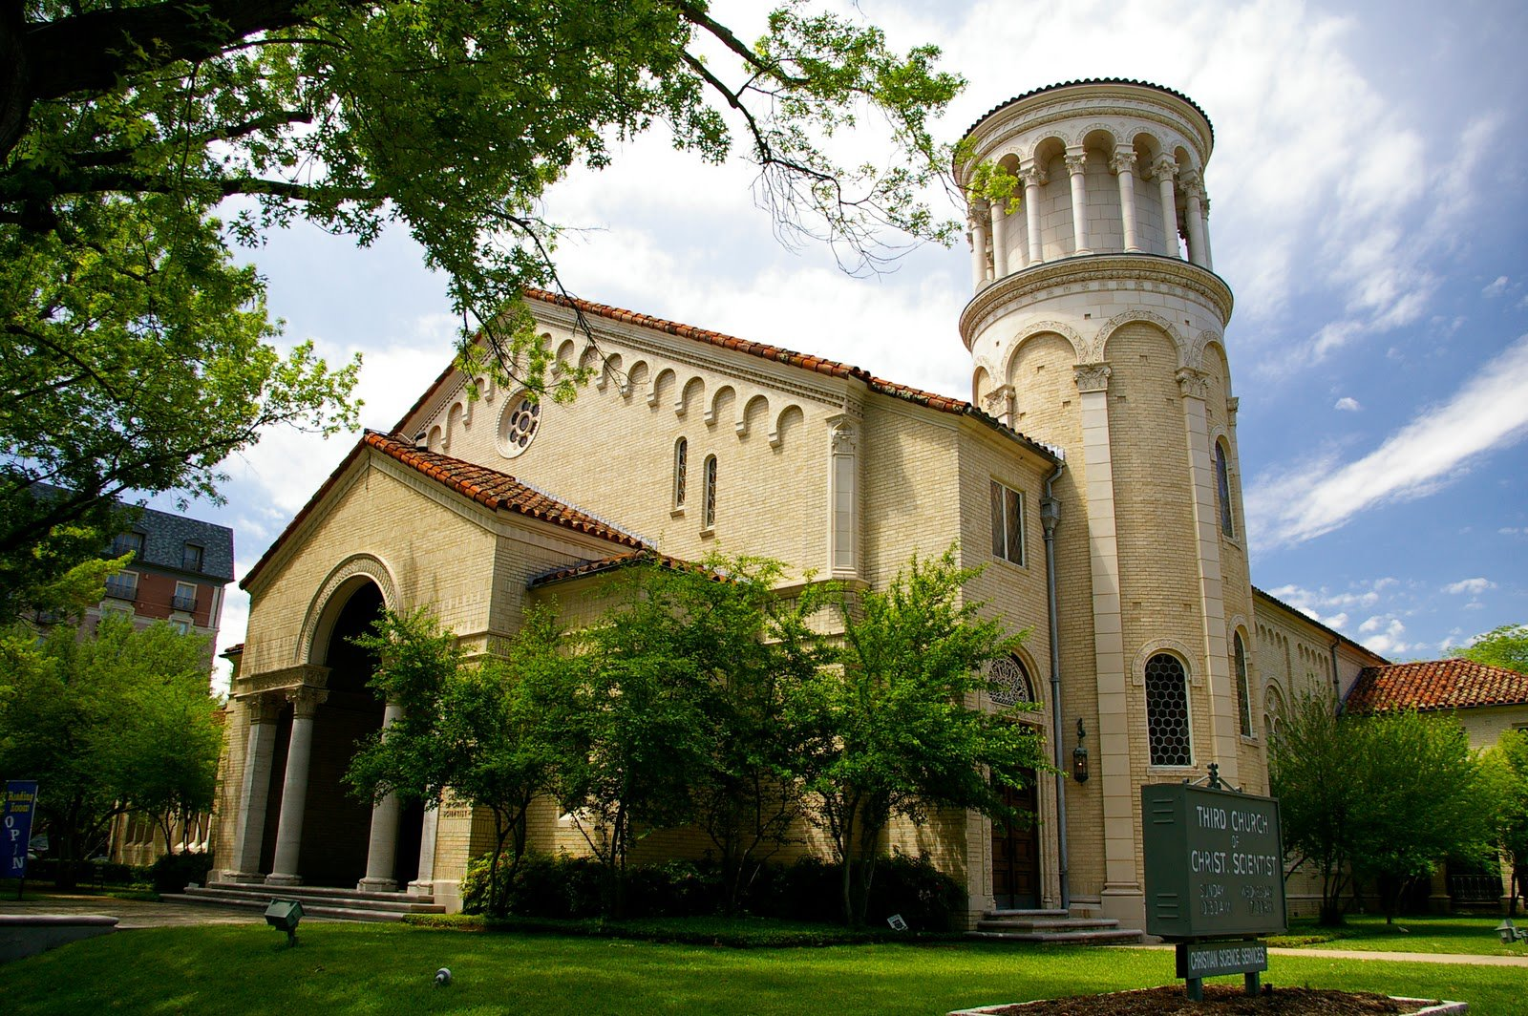

“The First Ten Years”

A Record of People and Times

Third Church of Christ, Scientist

Dallas, Texas

The Historical Climate of 1924-1934

To understand the magnitude of an accomplishment, it sometimes is necessary to know the historic events that stirred men's hearts, to remember the economic situation of an era, and to evaluate the progress of races and groups, as well as to recall the present day inventions that were not in use nor even dreamed of at that time.

By subtracting the present and stepping back in time to the decade immediately after World War I, we find the Christian Scientists of Dallas, Texas, living in a nation that was principally conservative in politics and in social philosophy. There was grave concern for high tariffs, demands for tax reduction, and government support. War debts, which were uncollectable, took on alarming economic proportions. Headlines in the newspapers constantly highlighted reparation, armaments, Japanese aggression in the Far East, the struggling and practically impotent World Court, and the peace movement. Women, new at the polls, timidly entered politics.

Prohibition came into the vernacular, and referred to a legislative act which prohibited the manufacture, sale, and distribution of alcoholic beverages. In the wake of this legislation came a new menace, —racketeers and crime syndicates.

In the background of these world situations that occupied the Congress, the press, and the concern of millions was a national economy marching inevitably toward the worst depression the United States has ever known.

Many historians concur in the opinion that the economic depression of the late 20's and early 30’s would have come no matter who had been president of the United States in 1929. The stock market crash, which occurred in October, was but the last resounding note to the fall of rugged individualism and the beginning of a socialized economy in the United States.

Millions of investors lost their savings, thousands were forced into bankruptcy, debts mounted, purchases declined, factories cut production or shut down, farmers abandoned their homesteads and moved away. Generally, the 20's and 30's can be classified as an era of materialism. Everywhere there was a profound distrust of reason, and a disregard of values. There were no grand ideas; only a sophisticated rejection of ideas. "The world," wrote Edwin Arlington Robinson, a distinguished writer of that period, "is a kind of spiritual kindergarten where bewildered infants are trying to spell God with the wrong blocks."

While philosopher, poet, economist, politician and business men struggled to understand the times and to adopt material measures to cope with unemployed youths wandering from town to town, mortgage foreclosures, teachers paid every other month, farms abandoned—Christian Science setting forth the unchangeable laws of God, was spreading throughout the nation and into nearly every country in the world.

In every city and state, Christian Science churches quietly and unobtrusively sprang up, their organizers and adherents being those "who hungered and thirsted after righteousness,” those who were tired of being disillusioned, hungry, sorrowing, and spiritually bankrupt. Those, who searched for a divine economy stable and sure, came. Those desiring a government based on Principle, unshakeable and changeless, came. They brought with them humble hearts, eager expectancy, and a willingness to be redeemed. With their pride gone, their wealth wiped out, there was little in a material way that they brought with them.

In Dallas, this quiet search for Truth was in operation, too. Christian Science grew in every part of the city, with churches springing up in Oak Cliff, in the downtown area, and in Oak Lawn.

Christian Science in Dallas

Christian Science came to Dallas, as nearly as can be figured, about 1890. Several people, having become interested in it, formed the first small group of students who met in the home of one of their number to read the literature and learn something of the teachings of this new Science. When a practitioner from another state came to Dallas, the group strengthened and soon after rented two rooms on the second floor of the Linskie Building, and a dispensary, later called a Reading Room, was opened.

In those days the Sunday service was conducted by those present reading from the Bible and Science and Health with Key to the Scriptures by Mary Baker Eddy.

The establishment of the movement in Dallas was met with uphill problems. The practitioner moved away, and the rooms were relinquished. The remaining members, about a dozen, again met in the home of one of the members.

In 1893, the group having grown to about twenty, rented a room in the Cockrell Building at the corner of Field and Commerce Streets. This room was dark and uninviting and had to be reached by a hallway that was dark and devious. The room was soon made attractive and approximately fifteen people began to attend regularly.

The service was conducted as before and hymns were sung without accompaniment. As the historian of that period wrote, " ... then a quiet dispersal with a renewed sense of sweetness and peace, for even then the abiding love and healing power of Christian Science were being manifest."

After a time, a Christian Science Society was organized and a cheap little organ acquired, which helped them with their singing. Attendance increased. Another practitioner moved to Dallas from a northern state, and it soon became apparent that larger quarters would be needed. But first they organized into a church and obtained a charter from the state. The next move took the newly formed church to the third floor of the Shumard Building on Main Street. Two long flights of stairs were climbed each Sunday for services and on Friday for testimony meetings.

Other problems were to attack the church, but with each problem, the Christian Science movement grew and prospered. Several other locations served the church as meeting sites, and at one time there were two churches functioning. But when it became apparent that all were earnestly seeking to practice the truth, unity came again. The two groups surrendered their state charters and jointly reorganized as Dallas First Church of Christ, Scientist. Later the name was changed to First Church of Christ, Scientist, of Dallas, Texas.

In 1910 a valuable lot was given to the church and preparations to build began at once. The first service was held in the new building on Communion Sunday, January 21, 1912. The Christian Science movement was growing so rapidly that the seating capacity of 990 in the new edifice was soon taxed to the limit. The Sunday School had an enrollment of 250 students, and both services were conducted at the same hour.

By the end of 1923, the auditorium was practically overflowing, and it was necessary that another church in the Dallas area be added, although Second Church of Christ, Scientist, had incorporated sometime earlier in Oak Cliff.

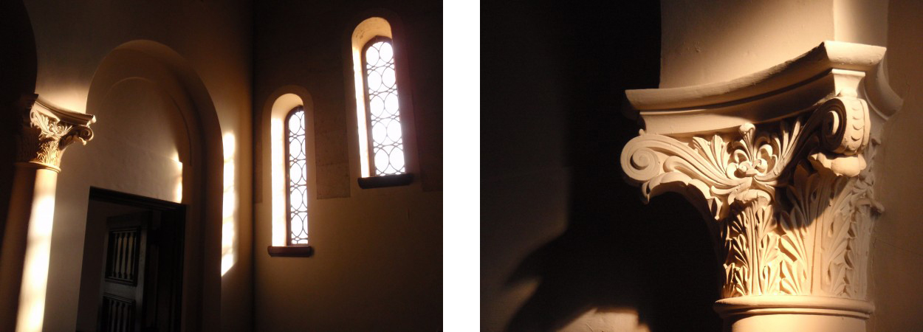

Third Church—It's Formation and Building

March 28, 1924, forty-six members of First Church held a meeting with the purpose of taking preliminary steps toward forming a third Christian Science church. This move was accomplished with the knowledge and the wholehearted cooperation of First Church.

The first meetings of the embryo group are testimonials of strength, courage, love, and cooperation. The parent church was apprised of every step the group was taking, and it provided meeting sites, advice, and encouragement all along the way. The minutes of those early meetings are filled with the gratitude the group felt for the loving support of First Church.

At the second meeting on April 7, 1924, in addition to electing temporary officers, a resolution was unanimously adopted to reaffirm the loyalty of the members in support of the Board of Directors of The Mother Church, the Manual, and The Mother Church, and the resolution was duly sent to The Mother Church along with information about the new church being formed.

Thereafter, Third Church moved swiftly toward an organized entity, and within a month held its first meeting of charter members in Stoneleigh Court, a suburban apartment hotel in the northern part of the city. Committees had been formed to find a suitable temporary meeting place, to draw up by-laws, and to see about incorporation. A Location Committee was appointed at the second meeting of the group to find a lot suitable for building a church, and this committee started functioning immediately. By the third meeting, this committee was making reports on available lots in the northern area of Dallas.

On April 17, 1924, the By-Laws Committee presented a set of by-laws for the approval of the church. The sections were voted on one by one, with amendments and word changes being
offered as each section was read. At that meeting the by-laws with the amendments were unanimously adopted. Again, at this meeting, the Location Committee reported that the lot at the corner of Rawlins and Coke Streets, mentioned at the last meeting, had been taken off the market.

The committee, which had been commissioned to locate a temporary meeting place, worked out a business arrangement with the manager of Stoneleigh Court to hold services in the large room on the eleventh floor, which was light and offered a pleasing view over the city and across the Trinity River Valley. The Reading Room and Sunday School rooms were to be on the first floor.

The first service of Third Church of Christ, Scientist, was therefore held at Stoneleigh Court on the eleventh floor, on Sunday, April 27, 1924. In the Sunday School room on the first floor the newly elected superintendent, who had prepared for about 40 pupils, found herself trying to find classes and teachers and chairs for the 100 and more who came that first Sunday; while upstairs, the two readers stared out over a packed room—an audience eager to participate in the first service of the newly formed church.

On June 18, 1924, a charter was obtained from the State of Texas.

The first year there were fourteen membership meetings, including the annual, semi-annual, and quarterly meetings, which sometimes lasted until the early hours of the morning. As one charter member recalls, "They were so inspiring, I never realized how late it was." Another said that so many meetings were held the first few years that her husband jokingly remarked, "If we turned our car loose, it would go to the church all by itself."

At a called meeting, May 1, 1924, the President announced the purpose of the meeting as one to consider the proper action to be taken to promote interest in the periodicals and other matters pertaining to the spiritual welfare of the church. At this meeting, it was voted to take orderly steps to insure 100% support from the membership in the matter of subscriptions to the periodicals. A further motion carried to send a monthly check to First Church of Christ, Scientist, Leavenworth, Kansas, to help assist in carrying on prison work at Leavenworth Prison.

These two motions coming about six weeks after organization may be considered as weathervanes that set the tenor of the future activities of Third Church, for at each successive meeting spiritual progress was emphasized and then put into practice through unselfish donations of both time and money. At the next meeting in May, 1924, the membership was plunged into the fight to help get the "Monitor Peace Plan" adopted in the Congress of the United States.

Another special meeting was not called until July 15, at which time the State Committee on Publication spoke to the members on impending legislation in the Texas Legislature which would limit the free practice of Christian Science. Support for the Committee's activity was pledged.

At the quarterly meeting in August of that year, Third Church adopted a motion to set aside the collection on the second Sunday in November to be given to the General Fund of The Mother Church, and the collection of the second Sunday in May to the Benevolent, Real Estate, and Relief Fund of The Mother Church.

In October, 1924, a called meeting reported a very small amount in the treasury of the church. The membership voted that the collection plates be passed then and there to take up money for the Fair Activities Fund, an activity needing immediate attention, with any surplus to go into the General Fund of the Church. It was then moved and adopted that a permanent lecture fund be maintained.

At the next meeting, three weeks later, information was given to the membership about building Pleasant View Home. A motion was then made to take a collection at the meeting for the purpose of sending a donation to The Mother Church for Pleasant View, and to announce from the desk on subsequent Sundays that a subscription list was being made for this purpose. The motion was carried by a rising vote.

Then in December, at the next to last meeting of this less than one-year-old church, the Location Committee reported on three lots suitable for the new church building. They were:

NE corner of Oak Lawn and Rawlins
SE corner of Rawlins and Wellborn
SE corner of Throckmorton and Hawthorne.

No action was taken except to advise the committee to continue looking.

At the December 9 meeting, a new site was mentioned by the committee at the corner of Hawthorne and Oak Lawn, but it was under option and not available at that time. A motion was then made to purchase the lot at the corner of Oak Lawn and Rawlins. Action on the motion was deferred.

When the membership met in February of the next year, the committee reported that the option had finally expired on the lot at the corner of Oak Lawn and Hawthorne, and a motion was then made to buy it.

Nineteen twenty-five saw further work being done on national and state legislation, prison work, increasing the number of lectures given per year to three, and gratitude for every step the new church was making. Letters of gratitude went out to everyone within the church who had done a special job, expressions of gratitude were made for good, for each other, for progress, and for lectures.

Not until January, 1926, was a Building Committee formed. The five members that made up the committee were elected by ballot. Such was the demonstration made by the church in its choice of a committee that only one member resigned, during the nearly six years of its functioning, and that was because he was elected First Reader. Nor was any member replaced, nor was any added to it, except the replacement for the Reader.

At the annual meeting in May of that year, the Building Committee made its first report and stated that nothing further could be accomplished by it until an architect was selected. At the semi-annual meeting that year in November, three leading Dallas architects presented plans and sketches to the membership and answered questions concerning ventilation, cooling, lighting, seating capacity, and acoustics. One architect presented a modern design, octagonal in shape, patterned after a St. Louis church. Mr. Mark Lemmon presented a sketch that was described in the minutes as a "Spanish type."

In December, after having had about two weeks to study all three plans and sketches, the membership voted in favor of the sketch submitted by Mr. Lemmon.

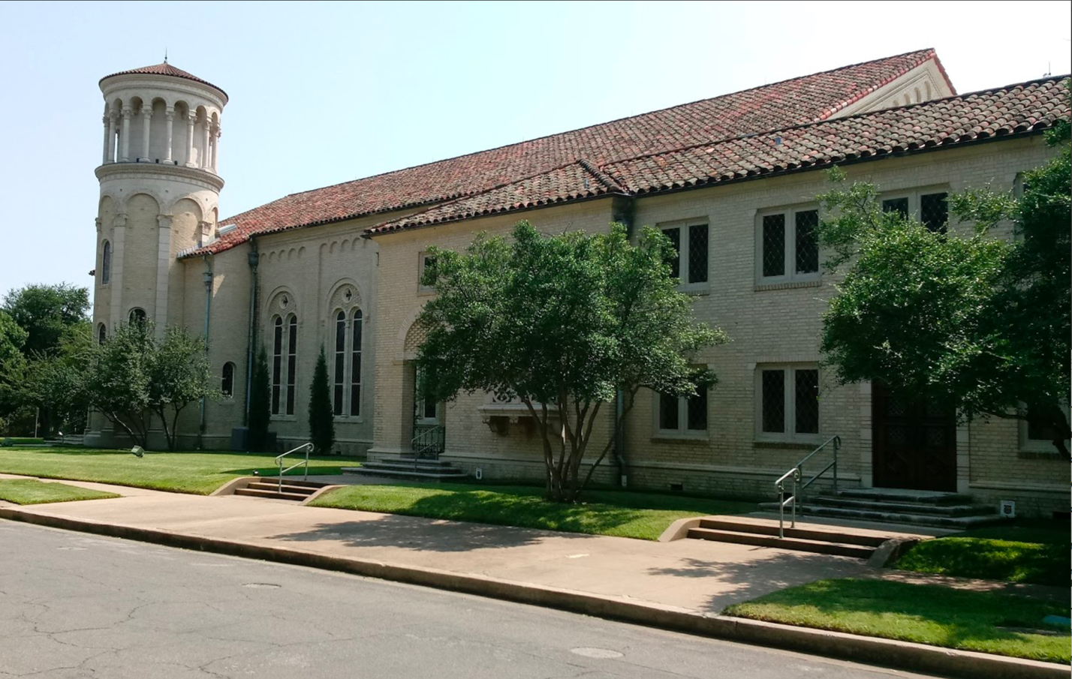

Thereafter, the emphasis in all meetings was on metaphysical building. In 1927, there were eighteen church meetings, plus numerous committee meetings, and called board meetings. The architect worked closely with the Building Committee and often appeared at church meetings to discuss points then under consideration. At no time did Third Church abandon its philanthropic projects, its donations to the various Mother Church funds, or its interest in local, state, and national legislation. The members even voted to increase its fee beyond the minimum paid
to lecturers for their services.

The membership in 1928 got down to the business of raising funds for church construction, it being pointed out by the Building Committee that the plans were progressing faster than the cash was accumulating. Unsigned pledges were asked for at this meeting and the collection plates were passed.

Final building plans were adopted in October, and immediately a letter of thanks was sent to all connected with the project up to that point. A letter was sent to Mr. Lemmon thanking him for the efficient way he had worked, and a check for his fee was also enclosed. The building fund at that time had reached $17,675.71 with unsigned pledges of $13,555 to come; notes receivable amounted to $10,350. Jewelry often appeared in the collection plates, as well as deeds to property. These were sold and the cash placed in the building fund.

In January, 1929, it was voted to have at least one meeting per month discussing the spiritual side of church building. Thereafter, subjects covered by the meetings ranged from "God's Measurement of Love", "Neighborliness," "The Grace of Gratitude," "Love", "Happiness," "The Joy of Church Building", to "Humility".

When the building fund had reached $44,000 the membership made several starts toward letting contracts for the building, but something prevented these negotiations. In April, 1929, a letter was read to the membership from the Secretary of the Trustees Under the Will of Mary Baker Eddy stating that it was their advice to have on hand at least one half of the funds necessary to complete a church before starting to build and that churches would save themselves much trouble if they had two­ thirds, or even three-fourths of the amount necessary.

In July consideration was given to purchasing the land behind the church lot where an apartment house was being considered, but nothing came of this move although the subject came up at several meetings.

On the night of October 29, 1929, the night when most of the citizens of the United States were reeling under the news of the Stock Market crash, the church voted to start building when the necessary 50% of the actual construction cost was on hand.

However, it was to be another year before steps were taken for the actual building to commence. In September, 1930, all previous motions restricting the building of the church were rescinded, and a motion adopted to build the entire church in accordance with the original plans and specifications.

A committee was appointed to look into securing a bank loan for financing the construction. When the president of the First National Bank was approached about lending Third Church
$100,000, he said, "Sure, we'll lend you the money. We believe in that church. We like the way Christian Scientists work." Years later a member of Third Church, himself a banker, said, "This was from a hard-nosed banker who knew that very few banks want church loans."

Actual construction of the building started around the first of October, 1930, and on Thanksgiving Day just at sunrise, November 27, 1930, the cornerstone was laid. As one writer recalled, "There [were] present only the Board of Trustees, the Building Committee, First and Second Readers, the Architect and the Contractors. The early morning was cloudy and somber, but as the stone was being placed, the clouds broke and the rising sun beamed through for a time, a promise and a prophecy as foretold in our Hymn Number 29. "Breaking through the clouds of darkness…”

In the corner stone was laid a Bible, a copy of each of Mrs. Eddy's works, a copy of each periodical, and the latest edition of The Christian Science Monitor.

By March 29, 1931, construction had progressed to the point where services could be held in the Sunday School portion of the building. As the writer quoted above wrote of that memorable day, "While the congregation sang praises to God, the birds on the outside seemed to be joining in gratitude. Now, the goal was in sight, and no error could prevent us from reaching it."

During all this time not one word of depression or lack crept into the minutes of the board meeting, or the membership meetings. The congregation often voted to make contributions to other church's building funds, to relief funds for flood or tornado sufferers, to further the work in prisons and universities. One consecrated testifier at one of the innumerable gratitude meetings stated that a condition of lack in her case had been healed when she subscribed to the periodicals. Other than that, the minutes reflect nothing but joy and gratitude; problems of great magnitude simply melted before the firmly held conviction that nothing could hinder the work that God had set their hand to.

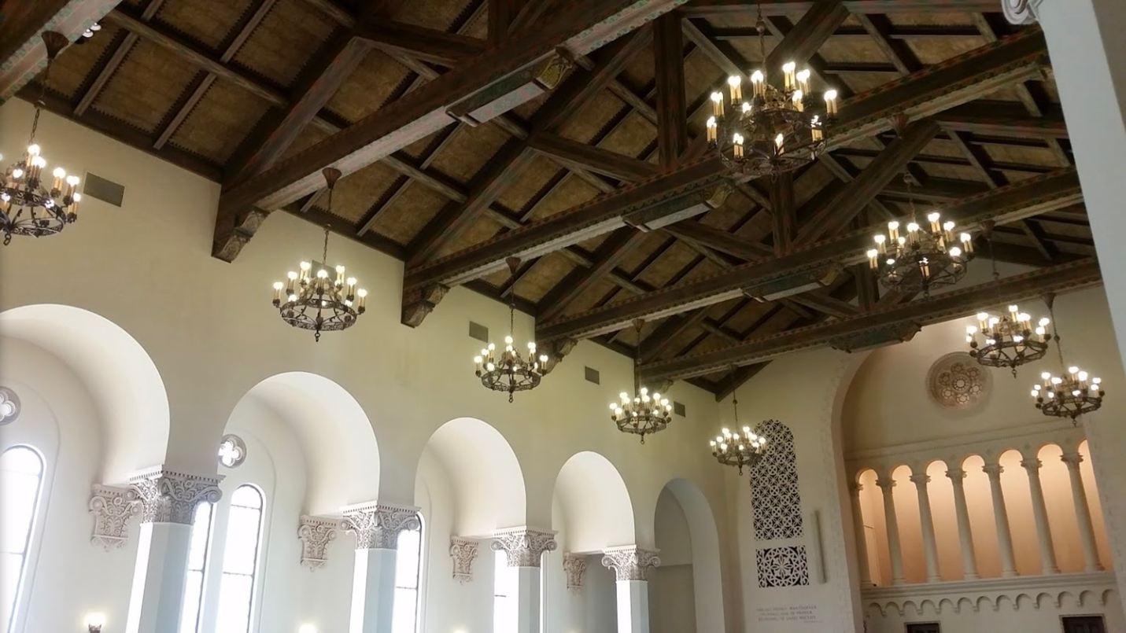

The first services in the completed auditorium were held on August 9, 1931. The organ was installed a few weeks later. On that day the membership was seven years and four months old and their expenditures for a building were approximately $215,000, half of which was paid for at that first service.

Due to the general economy of the period the contractors were able to hire the finest craftsmen in the area for work on the building. "If you will look up along the eaves of the roof," Mr. Lemmon suggested, "you will see some of the finest brick masonry in this country. The details are beautiful, and structurally the building is as sound as a dollar."

Stressing the times, Mr. Lemmon recalls that so many brick masons were out of work that it was a matter of vying with one another to get to work on this job. He further recalls that two brothers, artisans in their line, were responsible for the patterns in brick in the tower and eaves of the church. Never at any time before the building of Third Church, or since, has it been possible to get the quality at the price paid, as it was during the year of its construction.

On Thanksgiving Day, 1943, the building was dedicated, which in the Christian Science movement, indicates that the church is free of debt.

Architectural Excellence of The Building

The architecture and art of Europe betwen 500 and 1100 A. D. are called Romanesque, which of course means like Roman or derived from Roman. Though the style was derived in part from Roman art, it soon developed characteristics that made it distinct.

The 500 or 600 years in which the western world was dominated by the Roman Empire, saw the erection of many great monuments of engineering, but there were few churches built.

It was the Romans who first used arcades as a part of their palaces, aqueducts, and arenas. The Early Christian Churches, though not great in number, existed throughout the Roman Empire from the time of Constantine. Their structures largely adopted the general plan of having a porch across the front, a courtyard or foyer entrance, the long center section or body of the church with a high ceiling, and arcades on either side.

After the fall of the Roman Empire, there was no building to speak of at all. Temples and villas lay empty. The small amount of building that was done re-used fragments of imperial buildings. The early Christians refused to use pagan temples but had no objection to using the law courts, or basilicas, to worship in.

These low, oblong buildings were usually divided by two parallel of columns into a central space with an aisle on either side. At the end opposite the entrance was a bay that held the judge's seat. The Christians replaced the seat with an altar, and the basilica made an excellent church. Many of our own churches today can be traced back, step by step, to the basilicas.

At the time Mr. Mark Lemmon was asked by Third Church to submit sketches on speculation, he recalls that he had just returned from Europe where he had spent considerable time in Italy. He had made copious notes and drawn numerous sketches of architectural details of the Romanesque period. He recognized certain similarities in the climate and source of materials between the two countries. His mind was filled with the architectural excellence of round arches over tall narrow windows, and the grace of large doors with rounded tops, circular windows often called rose windows, terracotta trim, circular towers, arcades, and tile roofs. As soon as he accepted the task of submitting a sketch, he poured all his feeling onto the drawing board. As he says, "It was so right. Every detail just fit into the requirements your Building Committee submitted to me. Do you know something else? That church is substantially the very one I outlined on my first sketch. There were minor changes, of course, but the basic structure and detail of design are the same."

The vaulted ceiling caused considerable discussion during the planning period. The congregation finally voted to have an open ceiling rather than a closed one. It was then that Mrs. Lemmon, the architect's wife, contributed her artistic talents to the final plan. Using her years of art training, she drew the patterns and designated the colors to be used in the intricate designs that were painted onto the open beams in the vaulted ceiling of the church, as well as the beamed ceiling in the foyer.

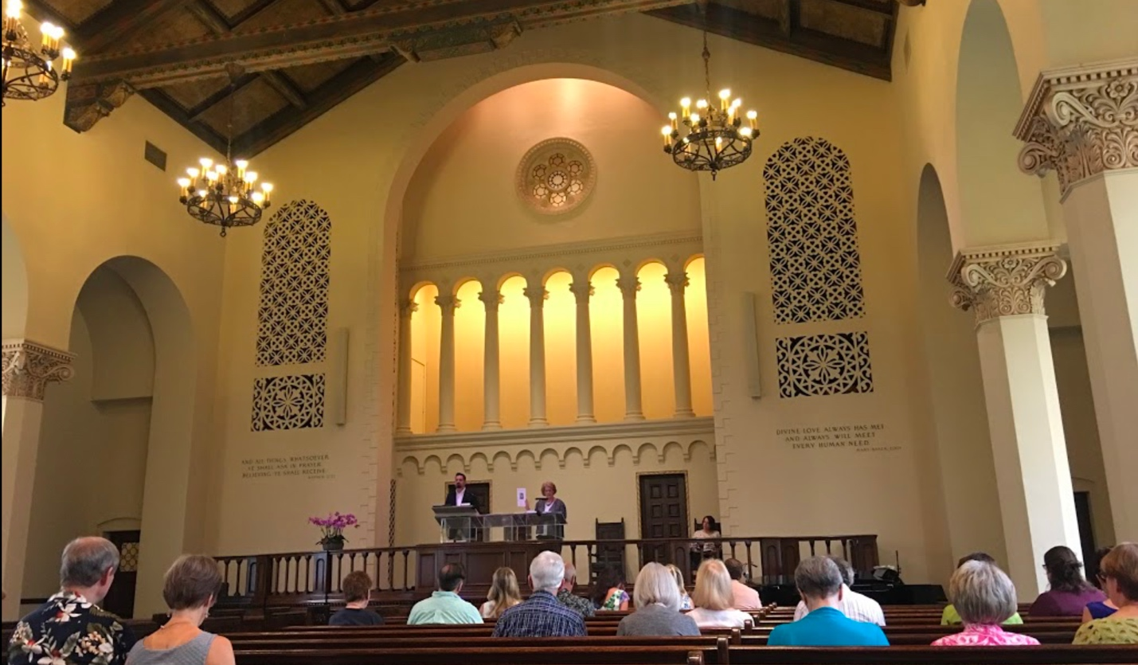

In April, 1938, an issue of Architectural Record, a technical journal for architects and builders, carried a feature story on Third Church of Christ, Scientist, Dallas, Texas. Numerous pictures show the arcaded porch on the Sunday School wing, the brick and terracotta details of the roof line and tower, a front view taken before the trees were planted and showing the rose window, the sweep of the wing where the Reading Room used to be, the wide front steps and the beautiful carvings over the arched front porch. An interior view of the auditorium shows the decorative arcades behind the reader's desk and the colonnades outlining the pews at either side. Two more views of the foyer are included, showing the circular stairway to the balcony, and the beamed ceiling of the main portion.

One of the cutlines reads, "In the planning of Christian Science churches definite requirements must be met. Since at services some statements are made from the floor of the auditorium as well as from the reader's desk, the acoustics must be perfect. The reader's desk must be visible from every other seat."

Another paragraph reads, "Between auditorium and Sunday School room, sound insulation had to be provided, as frequently both services are held at the same hour. For the same reason
there had to be separate entrances to the school section of the building.''

